LIBSPACE
Backend API Documentation
Project Title
LibSpace API – A Robust Backend for Library Operations.

Team Information
Team ID: SWTID-2026-6279
Team Size: 4
Team Leader: GOKULNATH S ( gokulnaths.831@gmail.com )

Team Members:
- GOBINATH V ( velusamygobinath@gmail.com )

- HARI M ( h898745@gmail.com )

- HARISHANKAR S ( harishankarsengodan@gmail.com )

1. Project Overview
LibSpace is a backend system designed to manage a personal digital library. The system allows users to create an account, log in securely, and manage their collection of books. The backend provides RESTful APIs for authentication and book management including adding, viewing, updating, and deleting books. Authentication is implemented using JSON Web Tokens (JWT) to ensure secure access to the system. This project demonstrates backend concepts such as REST APIs, authentication, database integration, and CRUD operations.

Objectives
- Build a RESTful backend API for a library system
- Implement secure user authentication using JWT
- Allow users to manage personal book collections
- Demonstrate CRUD operations using MongoDB
- Provide scalable backend architecture

Technologies Used
Technology | Purpose
Node.js | Backend runtime environment
Express.js | API development framework
MongoDB | NoSQL database
Mongoose | MongoDB object modelling
JWT | User authentication
Bcrypt | Password hashing
Dotenv | Environment variable management
Postman / Thunder Client | API testing

4.System Architecture
The backend follows a layered architecture:

- Routes Layer – Defines API endpoints
- Controller Layer – Handles request logic
- Model Layer – Database schema definitions
- Middleware Layer – Authentication and validation
- Database Layer – MongoDB stores application data

5.Features
- User Registration
- User Login
- JWT Authentication
- Logout using token blacklist
- Add Book
- View All Books
- View Single Book
- Update Book
- Delete Book

6. API Endpoints
User Authentication:

POST /api/authuser/register – Register a new user
POST /api/authuser/login – Login user POST /api/authuser/logout – Logout user
Book Management:

POST /api/book/add – Add a book
GET /api/book/all – Get all books
GET /api/book/:bookId – Get book by ID
PUT /api/book/:bookId – Update book DELETE /api/book/:bookId – Delete book

7. Authentication Flow
- User registers an account
- Password is hashed using bcrypt
- User logs in using email and password
- Server generates a JWT token
- Client sends token in Authorization header
- Protected routes verify the token before allowing access
- Example Header:
Authorization: Bearer Token

8. Database Schema
User Schema:

name
email password createdAt updatedAt
Book Schema:

url title
author user createdAt updatedAt

9. Error Handling
- – Bad Request
- – Unauthorized
404 – Resource Not Found 500 – Internal Server Error

Testing
The API endpoints can be tested using:
- Thunder Client (VS Code Extension)
- Postman
These tools allow sending HTTP requests and checking server responses.

Future Improvements
- Book category management
- Book search and filtering
- Reading progress tracking
- Recommendation system
- Role-based access control

Conclusion
The LibSpace backend provides a secure and scalable solution for managing a personal digital library. By implementing REST APIs, authentication, and database integration, the system ensures efficient book management.
This project demonstrates essential backend development concepts and can be extended further with advanced features.

OUTPUT SCREENSHOT:

USER REGISTER:

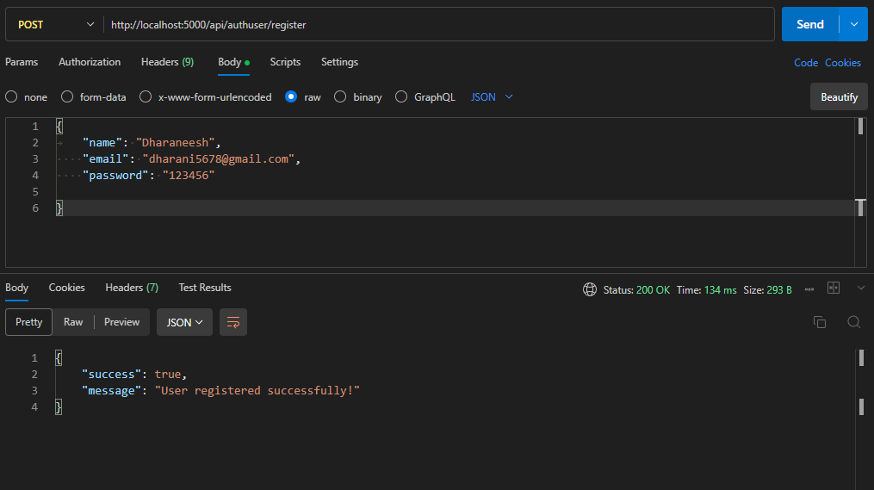

USER LOGIN:
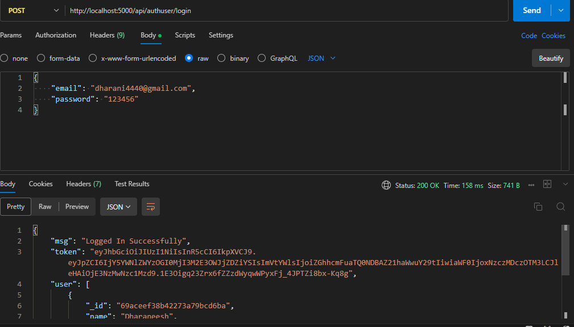

ADDING BOOK:
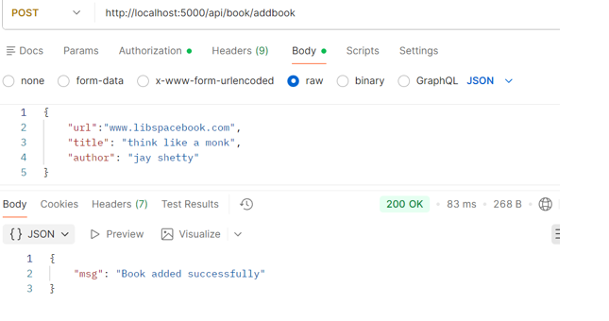

GET ALL BOOKS:
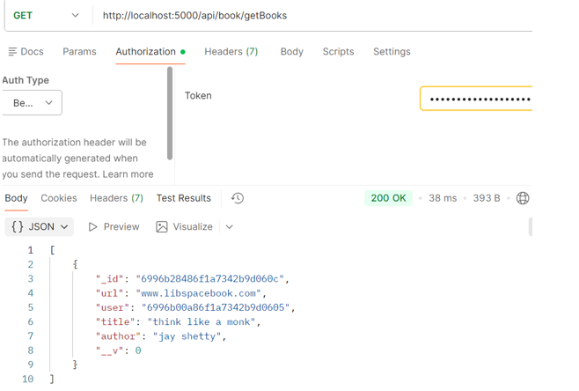

UPDATE BOOK:
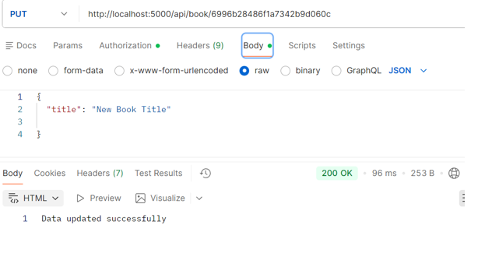

DELETE BOOK:
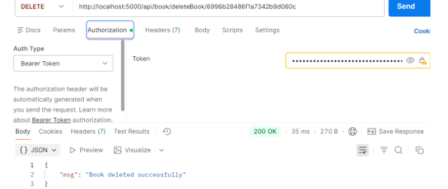

USER LOGOUT:
